Baseball Case Study
Problem Statement:

This dataset utilizes data from 2014 Major League Baseball seasons in order to develop an algorithm that predicts the number of wins for a given team in the 2015 season based on several different indicators of success. There are 16 different features that will be used as the inputs to the machine learning and the output will be a value that represents the number of wins.
-- Input features: Runs, At Bats, Hits, Doubles, Triples, Homeruns, Walks, Strikeouts, Stolen Bases, Runs Allowed, Earned Runs, Earned Run Average (ERA), Shutouts, Saves, Complete Games and Errors
-- Output: Number of predicted wins (W)
Importing all the required libraries:
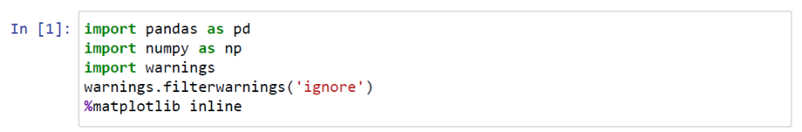
Importing the data:
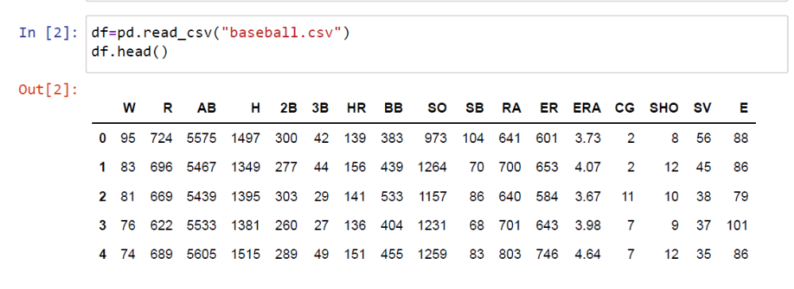

Data Analysis:
Checking if there are any null values present in the data
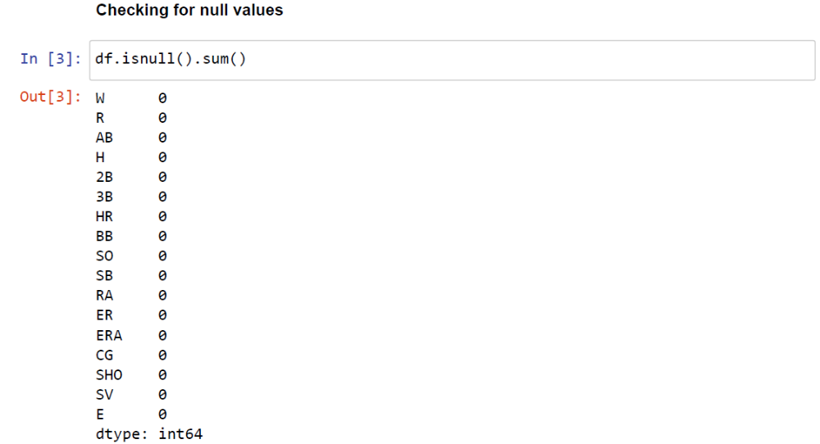
Seems there are no null points present in the data
To check the shape that is to find the number of columns and rows in the data
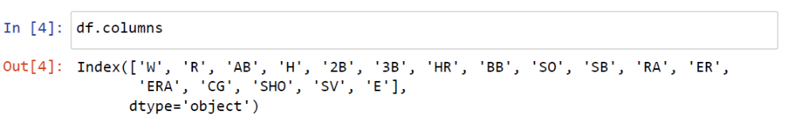

To know the data in detailed we use describe funtion
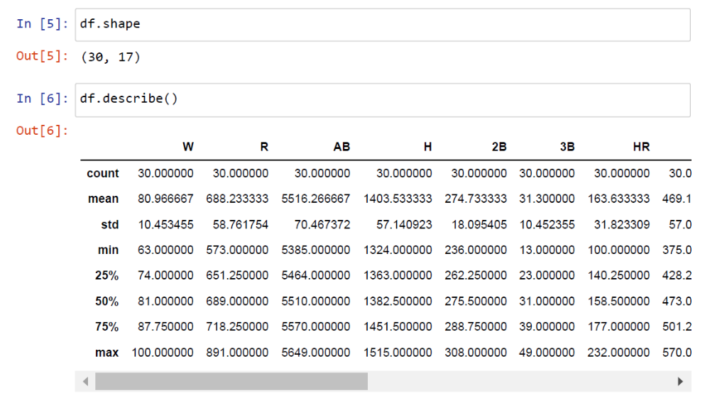
To check how many unique values are present in each column
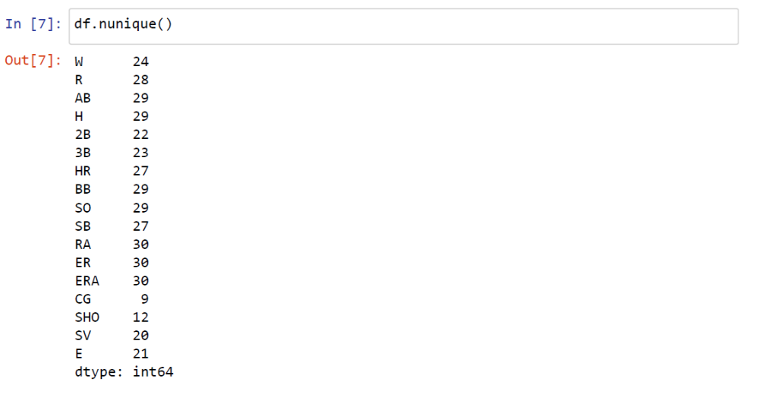

To check the datatype of each column present in the data
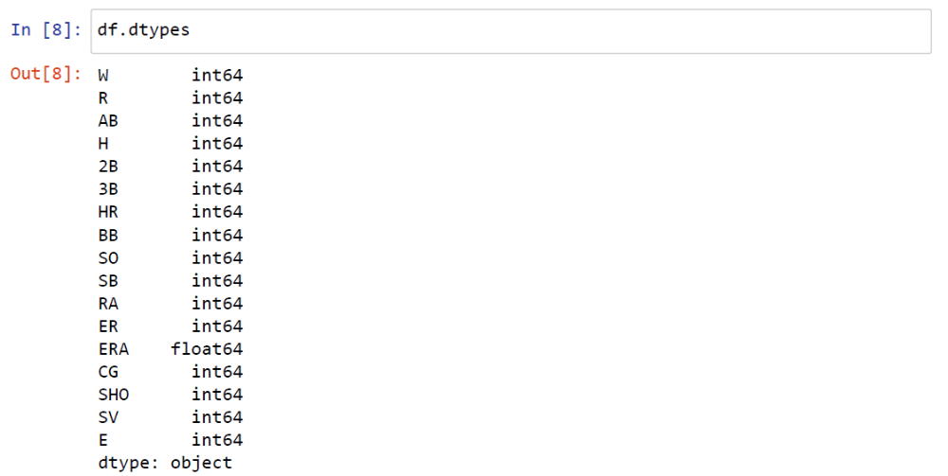
Below are the catplot graphs where each column is compared with the WIN column
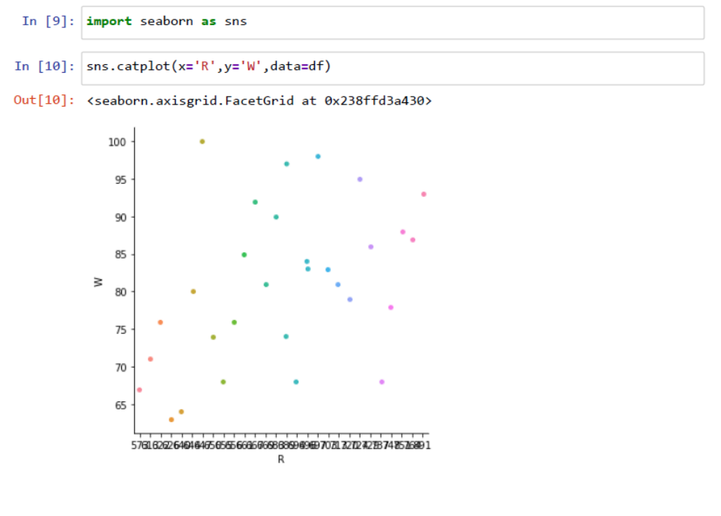
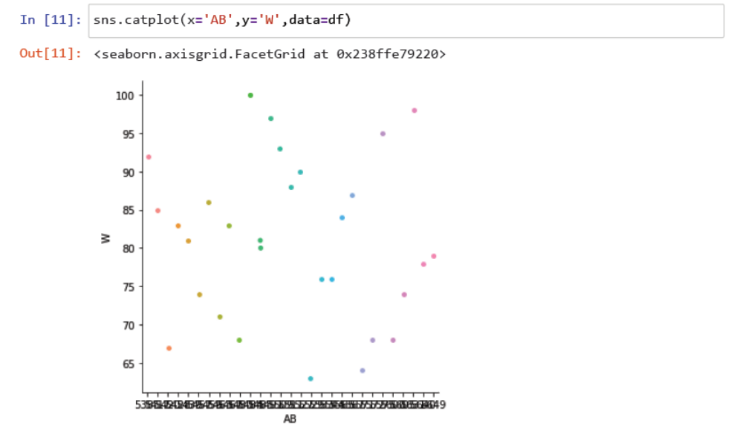
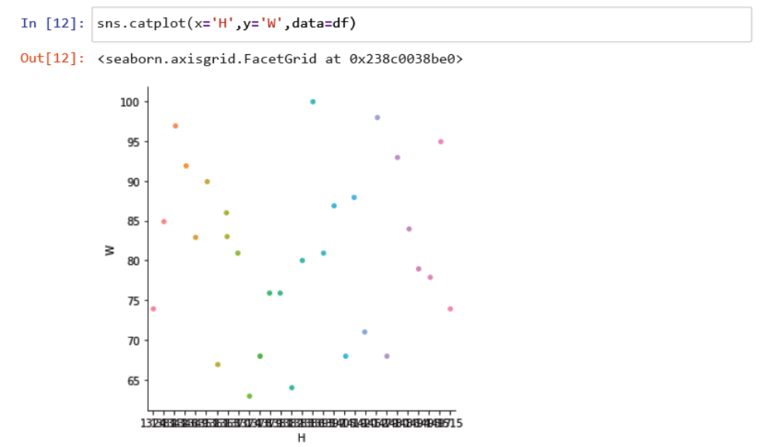
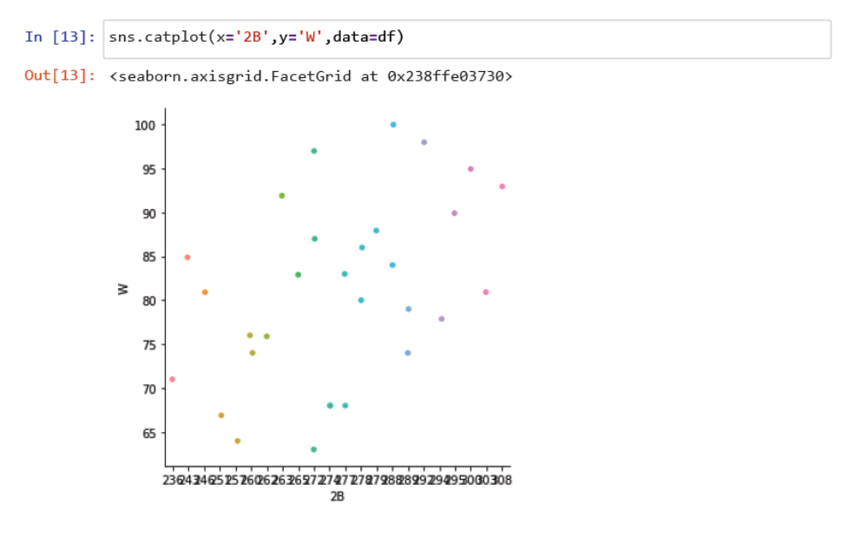
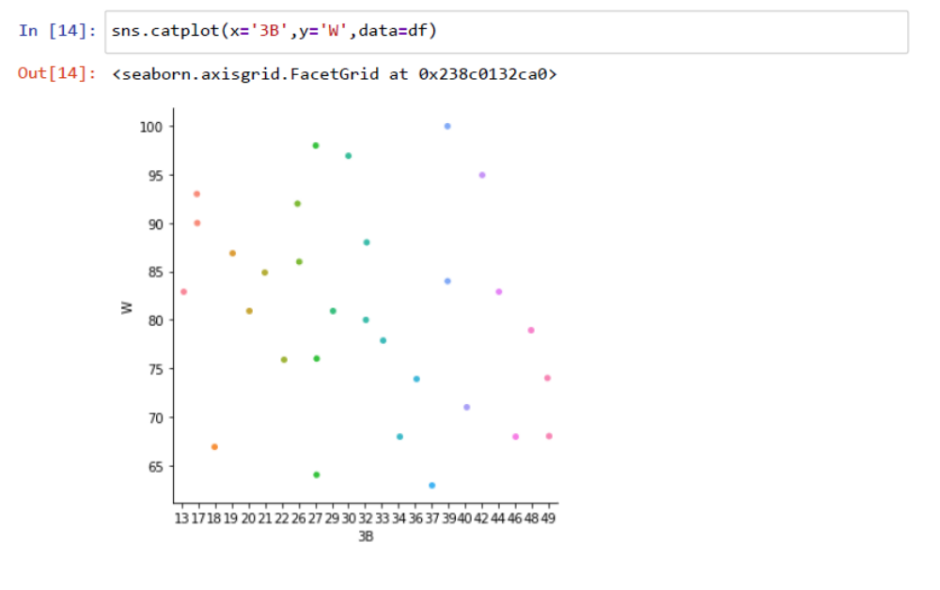
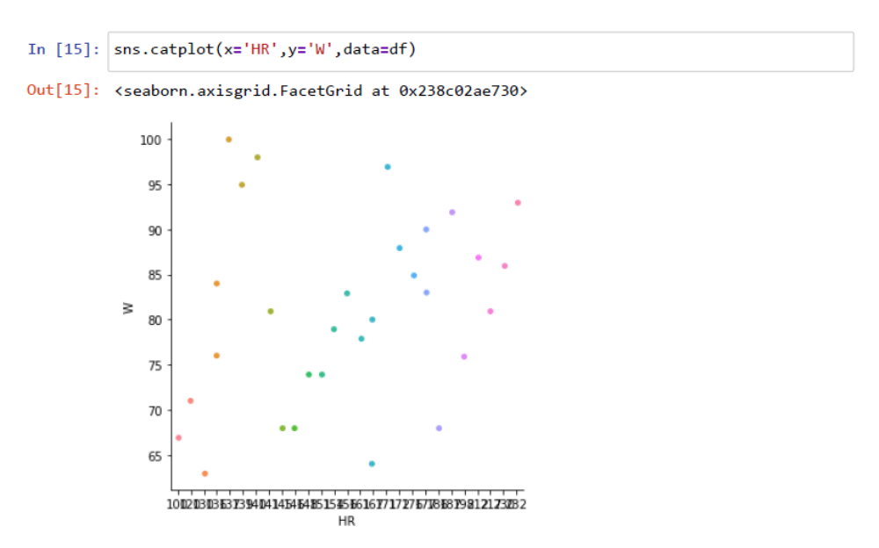
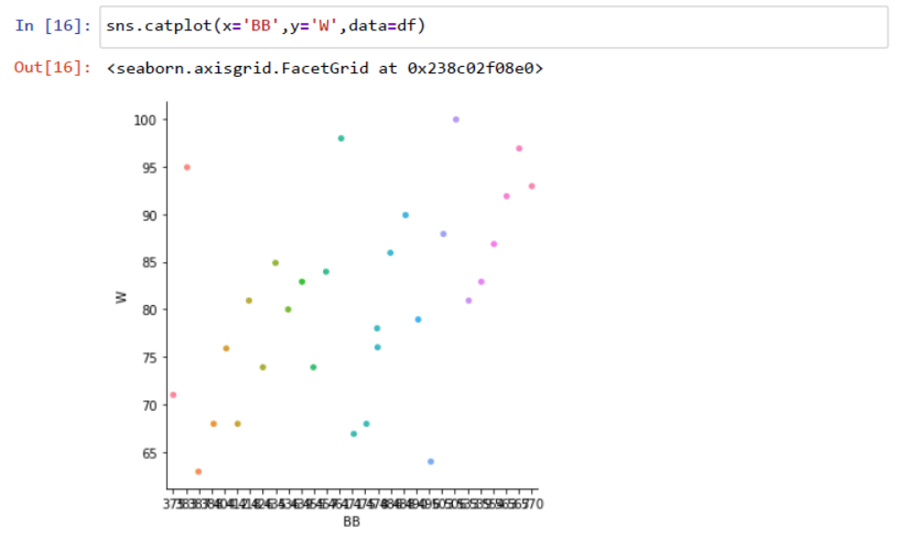
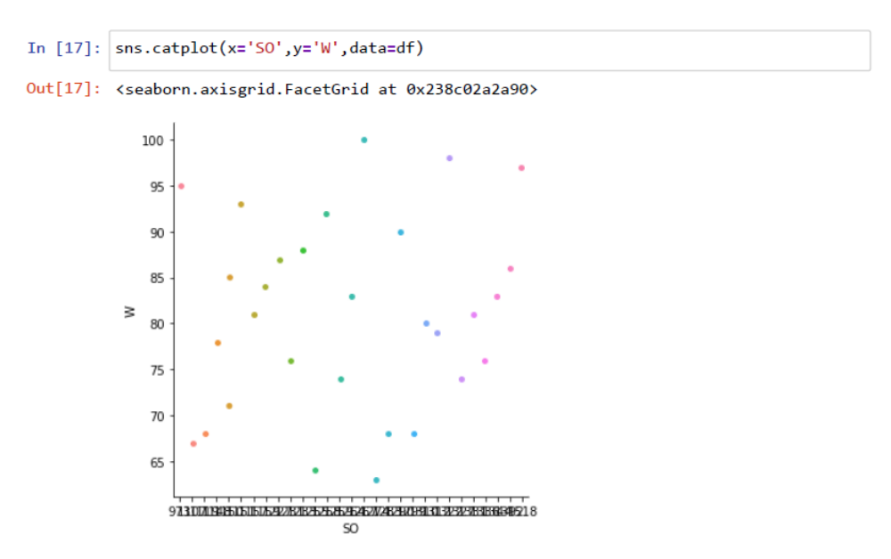
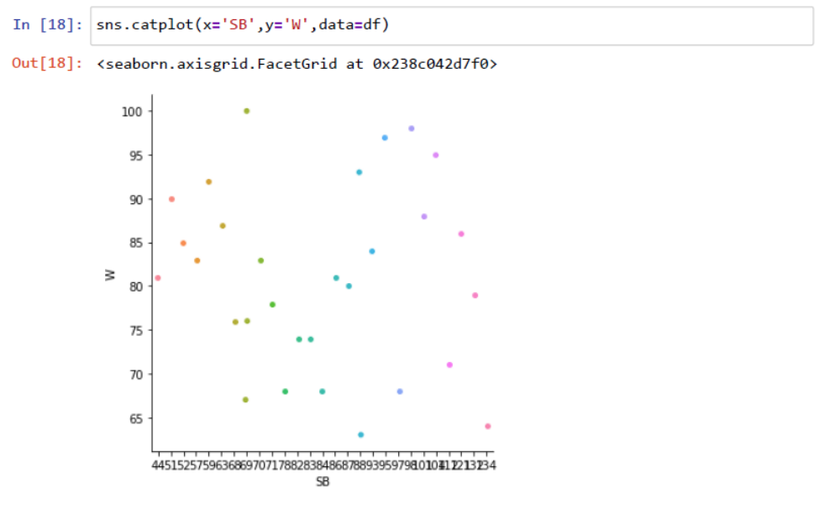
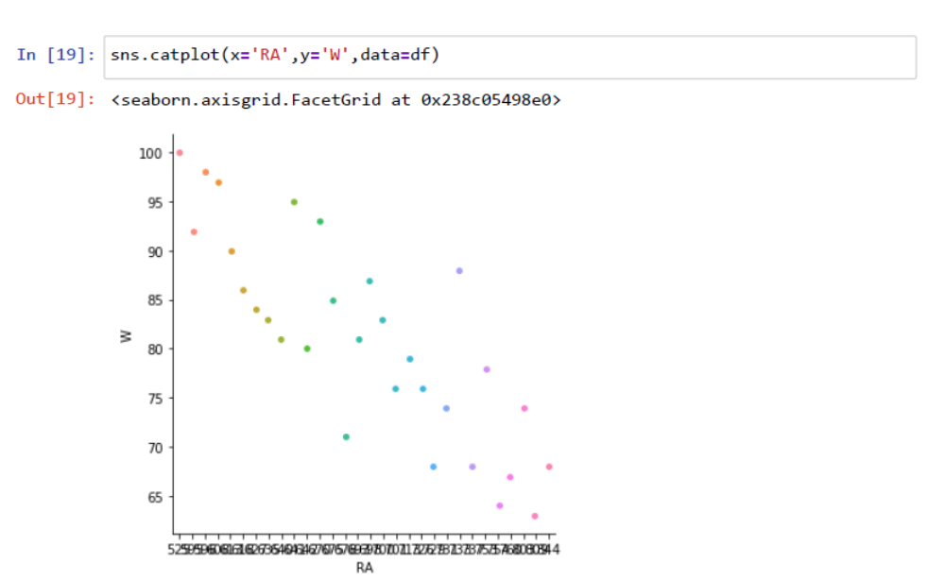
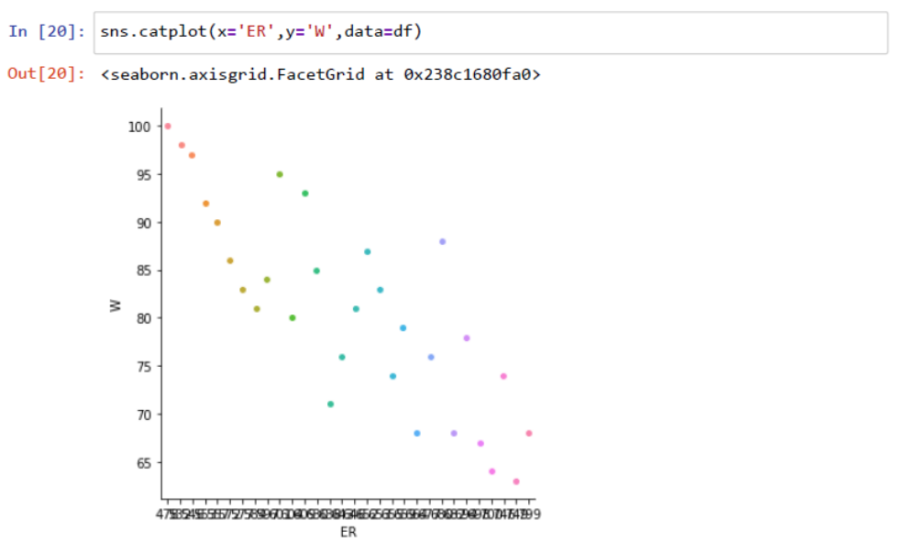
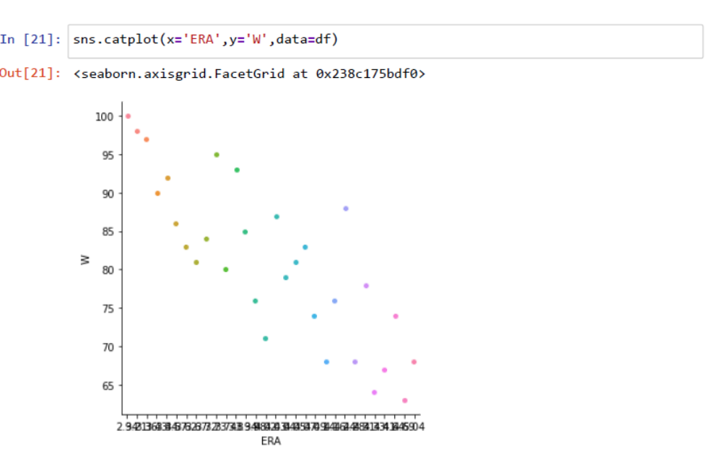
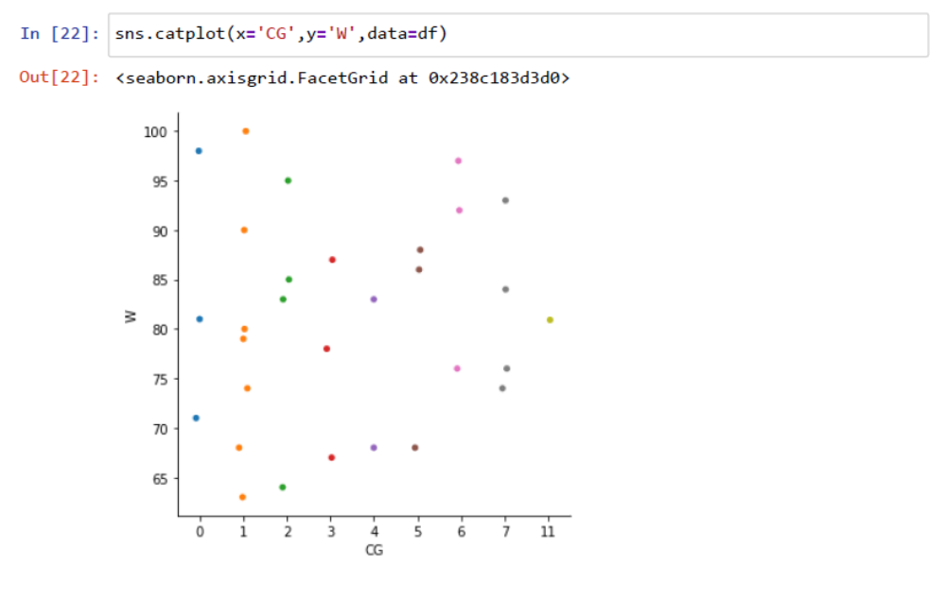
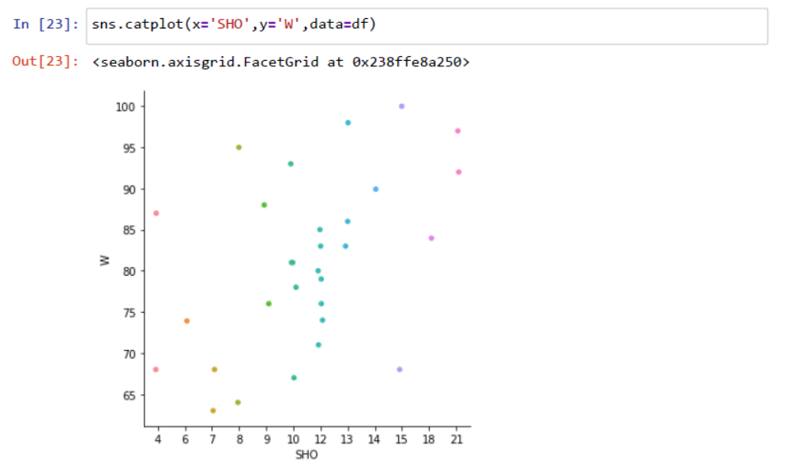
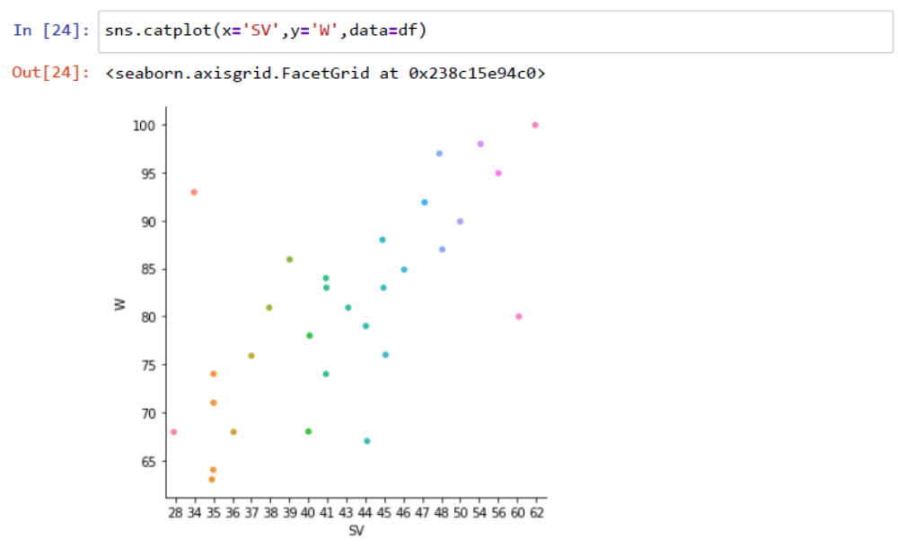
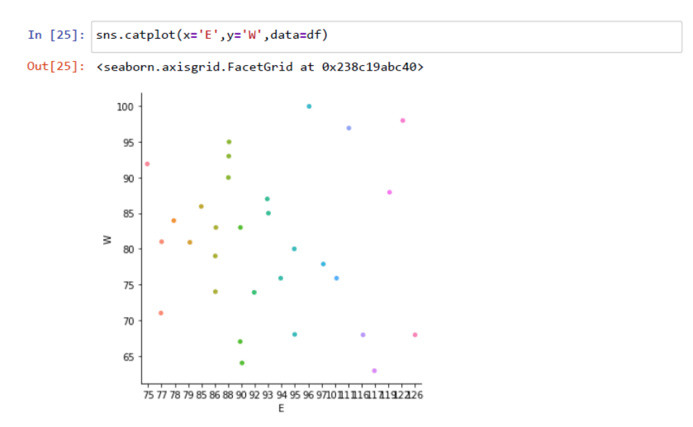

Visualizing the outliers using the boxplot:
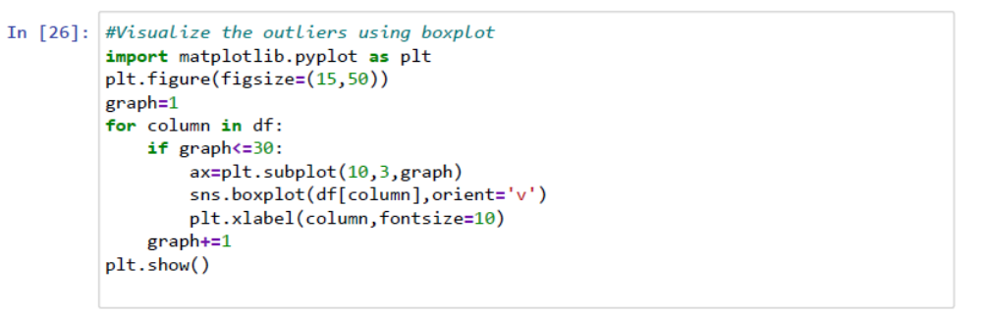
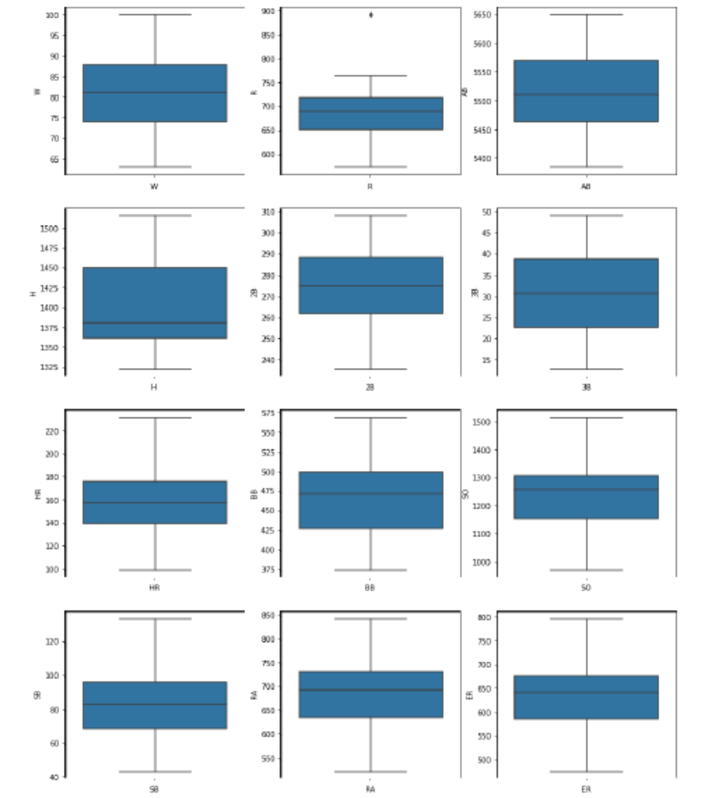
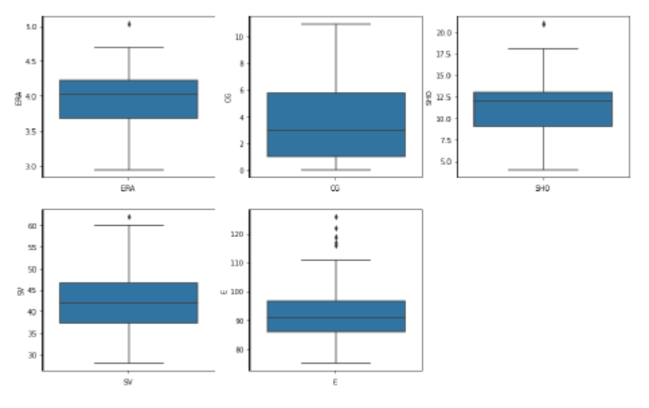
Removing the outliers by using z-score
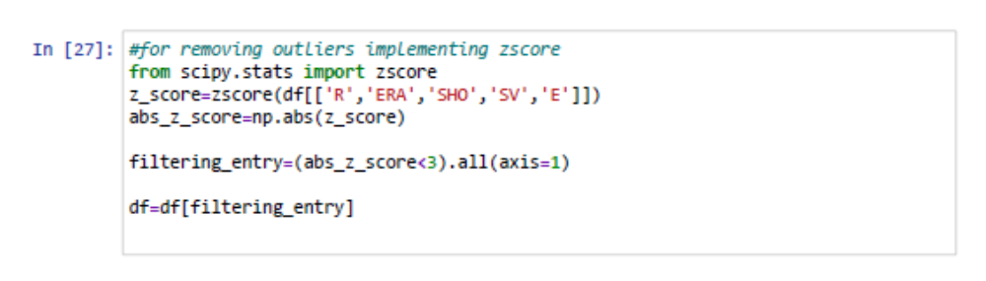
After removing the outliers the data ends up with 29 rows and 17 columns
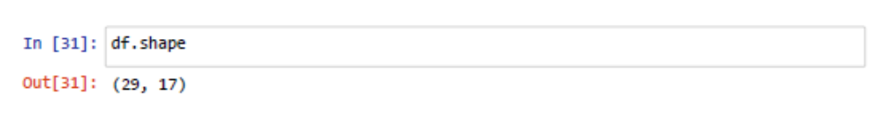

After removing the outliers, plotted the dist plot to check whether all columns have normal distribution
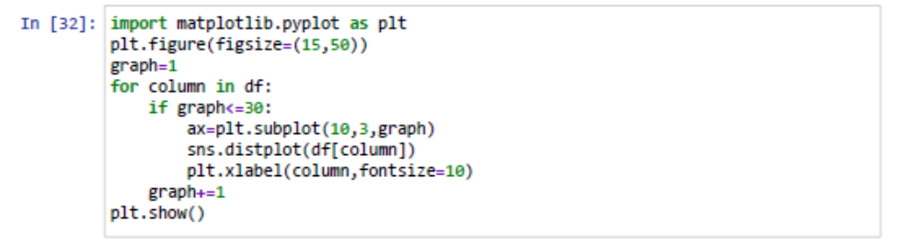
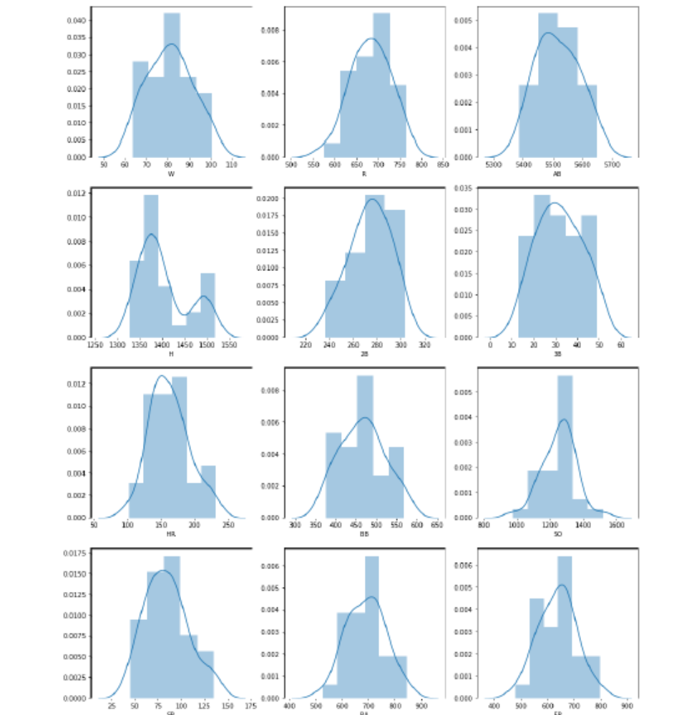
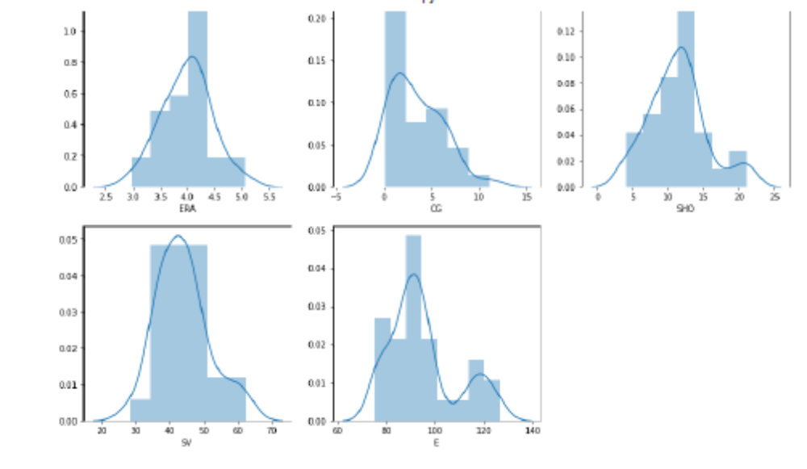
Now plotting the correlation graph to check the correlation of the data
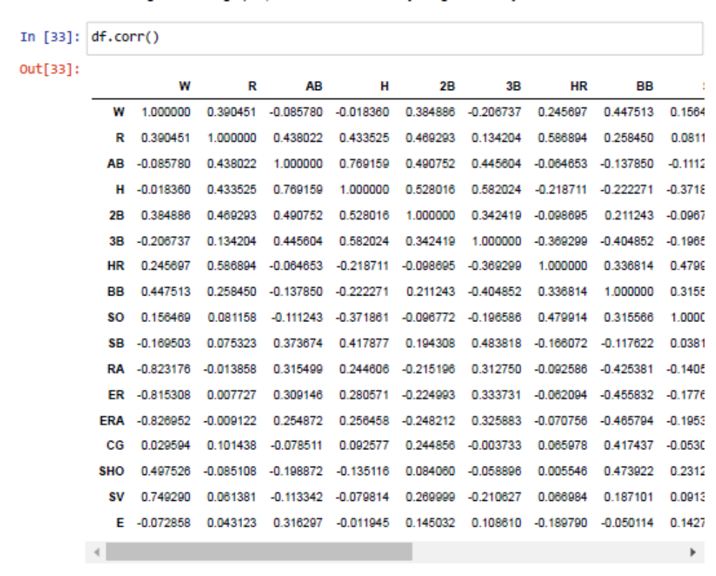
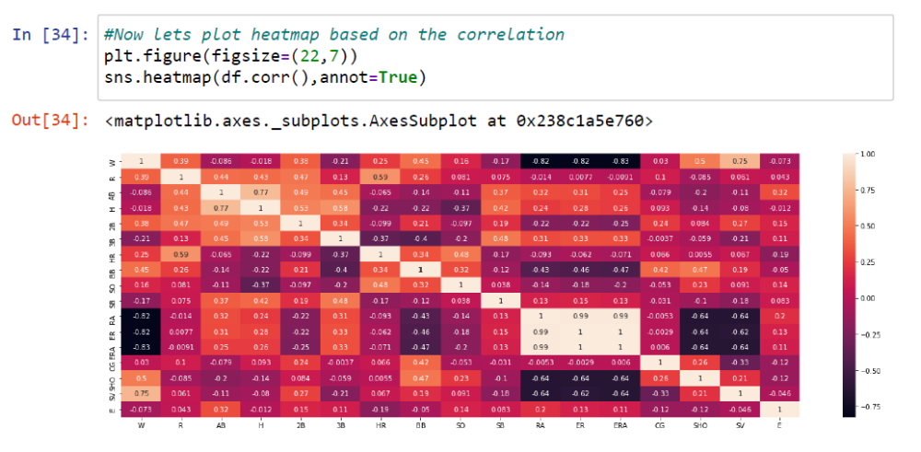
EDA Concluding Remarks:
- Seems there are no null values present in the data
- Every column has their own unique values
- By observing the cat plots we could see that there is quite good relation between every column to the Win column.
- There are outliers in 'R','ERA','SHO','SV','E.So performed the z score on only those columns
- And coming to the dist plot every column have the normal distributed data present in it
- Coming to the correlation graph, The number of runs, home runs, doubles, saves, shutouts and walks are highly positively linearly correlated.
- Stolen bases, runs allowed, earned runs are highly negative linearly correlated
- the remaining features have less to no linear correlation with no of wins
Preprocessing Pipe-lines:
Dividing the data into features and labels:
Here x is assigned to the input features of the model whereas y is assigned to the target.
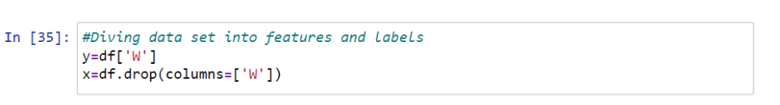
ANOVA:
Analysis of variance (ANOVA) is an analysis tool used in statistics that splits an observed aggregate variability found inside a data set into two parts: systematic factors and random factors
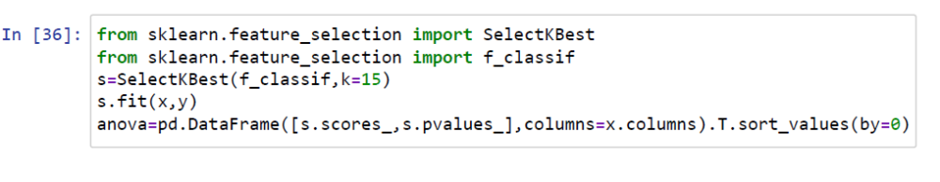
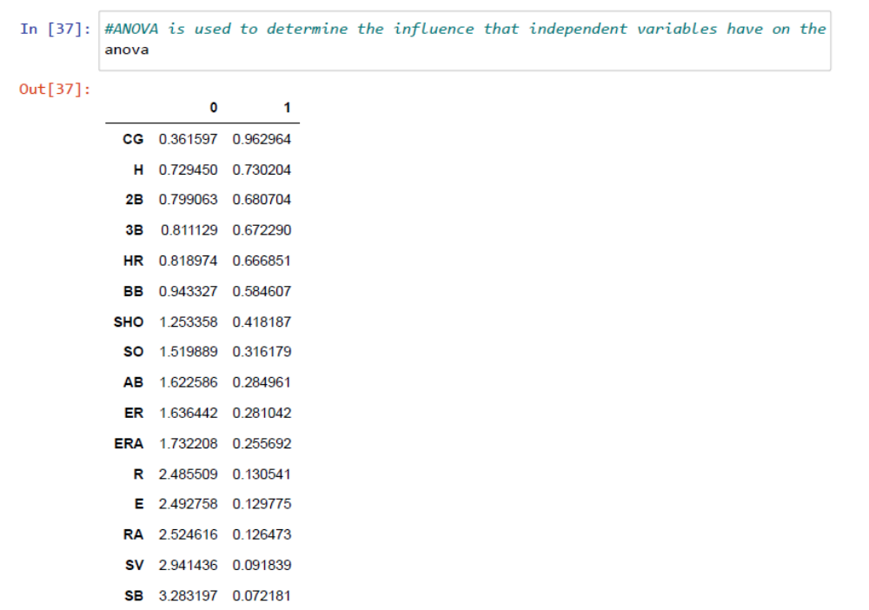
DATA SCALING:
Data scaling is a method used to normalize the range of independent variables or features of data. In data processing, it is also known as data normalization and is generally performed during the data preprocessing step.
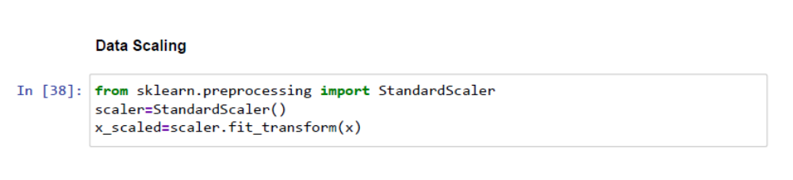
Building Machine Learning Models:
In the below piece of code, there is a function called classify where the data splitting is done , model fitting is done and accuracy of the model is calculated.
LogisticRegression , LinearRegression , DecisionTreeClassifier ,RandomForestClassifier , ExtraTreeClassifier , XGBClassifier are implemented by calling the classify function. After fitting with everything mentioned above,The highest accuracy is shown by LinearRegression
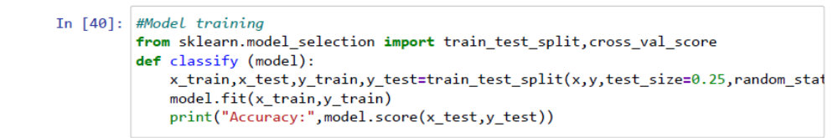
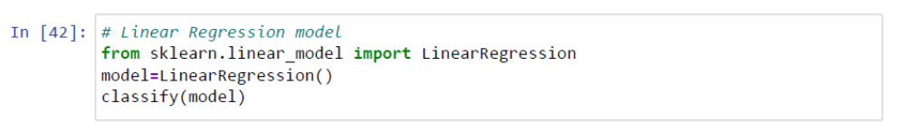
The below graph is the predicted vs actual outcome graph
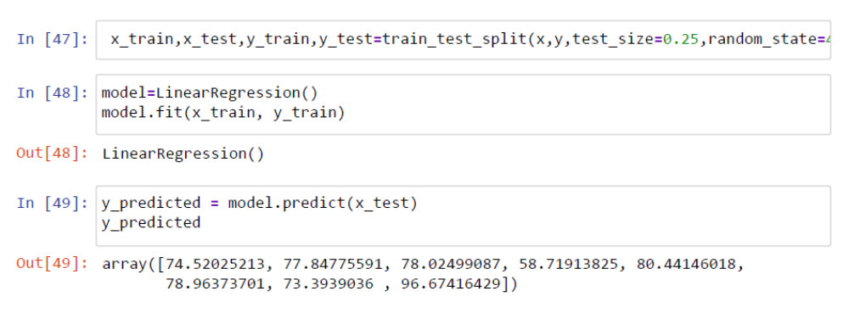
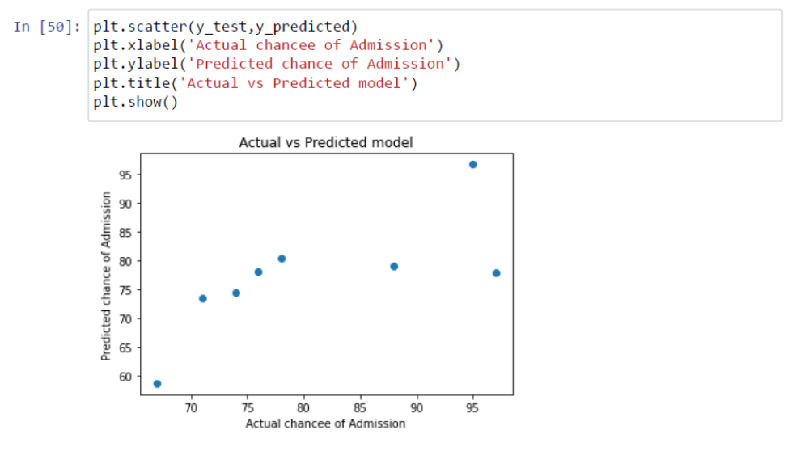
Cross Validation and GridSearchCV is done
Cross-validation is a technique in which we train our model using the subset of the data-set and then evaluate using the complementary subset of the data-set.
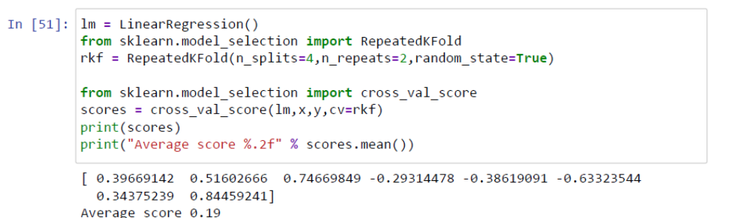

GridSearchCV is a useful tool to fine tune the parameters of your model.
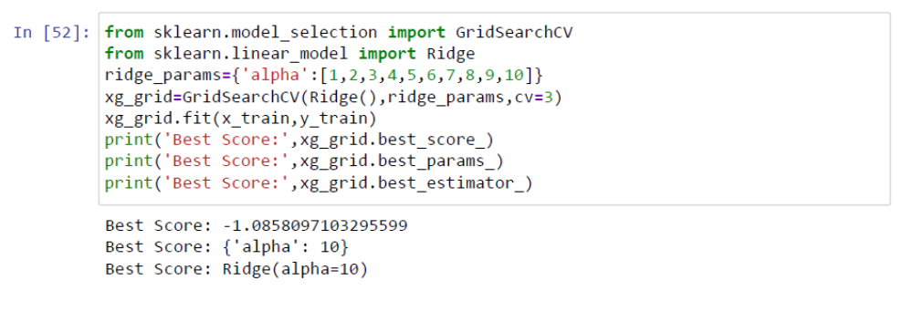

Below is the piece of code to save the best model as a pickle file
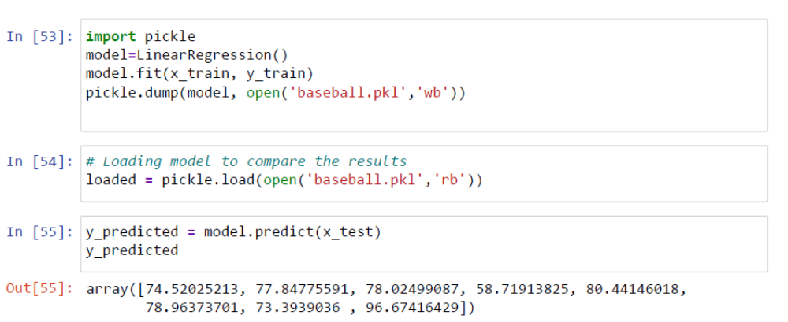
Concluding Remarks:
As discussed in EDA and storytelling the randomness of the dataset should be reduced by reducing the number of variables. Which was done by Cross Validation and GridSearchCV.

